Primary: Relationships (Sex) and Health
Education (RSHE) Policy
The Beeches Primary School



Author: | David French
Version: | 4
Approval date: | February 2026 to be implemented in September 2026
Next revision date: | September 2027
Approving / revision body lead: | Headteacher / Governing Body

Contents
1. Aims 3
2. Statutory requirements 3
3. Policy development 5
4. Definition 5
5. Curriculum 5
6. Delivery of RSE 5
7. Use of external organisations and materials 9
8. Roles and responsibilities 10
9. Parents’ right to withdraw 10
10. Training 11
11. Monitoring arrangements 11
Appendix 1: Curriculum map 12
Appendix 2: By the end of primary school pupils should know 13
Appendix 2: By the end of secondary school pupils should know 16
Appendix 3: Parent/carer form requesting their child’s withdrawal from sex education within RSE 22

1. Aims
The aims of relationships and sex education (RSE) at our school are to:
- Provide a framework in which sensitive discussions can take place
- Prepare pupils for puberty, and give them an understanding of sexual development and the importance of health and hygiene
- Help pupils develop feelings of self-respect, confidence and empathy, and cultivate positive characteristics such as kindness and integrity
- Create a positive culture around issues of sexuality and relationships
- Teach pupils the correct vocabulary to describe themselves and their bodies

2. Statutory requirements
As a maintained primary school, we must provide relationships education to all pupils under section 34 of the Children and Social Work Act 2017.
We are not required to provide sex education, but we do need to teach the elements of sex education contained in the science curriculum.
In teaching RSE, we must have regard to guidance issued by the secretary of state, as outlined in section 403 of the Education Act 1996.
We also have regard to legal duties set out in:
- Sections 404 to 407 of the Education Act 1996.
- Part 6, chapter 1 of the Equality Act 2010
- The Public Sector Equality Duty (PSED) (as set out in section 149 of the Equality Act 2010). This duty requires public bodies to have due regard to the need to eliminate discrimination, advance equality of opportunity and foster good relations between different people when carrying out their activities
At The Beeches Primary we teach RSE as set out in this policy.

3. Policy development
This policy has been developed in consultation with staff, pupils and parents/carers. The consultation and policy development process involved the following steps:
- Review – a member of staff or working group pulled together all relevant information including relevant national and local guidance

- Staff consultation – all school staff were given the opportunity to look at the policy and make recommendations

- Parent/stakeholder consultation – parents/carers and any interested parties were invited to attend a meeting about the policy

- Pupil consultation – we investigated what exactly pupils want from their RSE

- Ratification – once amendments were made, the policy was shared with governors and ratified

4. Definition
For the purpose of this policy:
RSE is about the emotional, social and cultural development of pupils, and involves learning about relationships,healthy lifestyles, diversity and personal identity.
RSE involves a combination of sharing information, and exploring issues and values.

5. Curriculum
Our RSE curriculum is set out as per Appendices 1 and 2, but we may need to adapt it as and when necessary.
We have developed the curriculum in consultation with parents and carers, pupils and staff, and taking into account the age, developmental stage, needs (such as cultural and religious needs) and feelings of our pupils. If pupils ask questions outside the scope of this policy, teachers will respond in an appropriate manner so that pupils are fully informed and don’t seek answers online.
We will share all curriculum materials with parents and carers on request.

6. Delivery of RSE
RSE is taught within the personal, social, health and economic (PSHE) education curriculum. Biological aspects of RSE are taught within the science curriculum, and other aspects are included in religious education (RE).
The school will make sure that:
- Core knowledge is sectioned into units of manageable size
- The required content is communicated to pupils clearly, in a carefully sequenced way and within a planned scheme of work
- Teaching includes sufficient and well-chosen opportunities and contexts for pupils to embed new knowledge, so that it can be used confidently in real-life situations
Relationships education focuses on teaching the fundamental building blocks and characteristics of positive relationships including:
- Families and people who care for me
- Caring friendships
- Respectful, kind relationships
- Online safety and awareness
- Being safe
Primary sex education will focus on:
- Preparing boys and girls for the changes that adolescence brings
- How a baby is conceived and born
Throughout each year group we will use appropriate material to assist learning, such as:
- Diagrams
- Videos
- Books
- Games
- Discussions and practical activities
Teachers will make sure that all pupils’ views are listened to, and will encourage them to ask questions and engage in discussion. Teachers will answer questions sensitively, honestly and appropriately for the age of the pupils.
The programme will be designed to focus on boys as much as girls, and activities will be planned to make sure both are actively involved.
The school will make sure that all teaching and materials are appropriate for the ages and needs of the pupils including any additional needs, such as special educational needs and disabilities (SEND).
At all points of delivery of the curriculum, the school will consult parents and carers, and their views will be valued. What will be taught and how will be planned in conjunction with parents and carers.
For more information about our RSE curriculum, see Appendices 1 and 2.
We may amend our curriculum content to respond to the needs and context of our pupils, to discuss issues affecting them in an age-appropriate manner. We will inform parents and carers of any deviation from our published policy in advance, and share any relevant materials on request.
These areas of learning are taught within the context of family life, taking care to make sure that there is no stigmatisation of children based on their home circumstances (i.e. families can include single-parent families, same-sex parents, families headed by grandparents, adoptive parents and foster parents among other structures), along with reflecting sensitively that some children may have a different structure of support around them (for example, looked-after children, young carers or kinship carers).
Across our school, we will also be mindful of the law and legal requirements, taking care not to condone or encourage illegal activity, such as violent action against people, criminal damage to property or hate crime.
  - Inclusivity
We will teach about these topics in a manner that:
- Considers how a diverse range of pupils will relate to them
- Is sensitive to all pupils’ experiences
- During lessons, makes pupils feel:
  - Safe and supported
  - Able to engage with the key messages
We will also:
- Make sure that pupils learn about these topics in an environment that’s appropriate for them, for example in:
  - A whole-class setting
  - Small groups or targeted sessions
  - 1-to-1 discussions
  - Digital formats
- Give careful consideration to the level of differentiation needed

  - Use of resources
We will consider whether any resources we plan to use:
  - Are aligned with the teaching requirements set out in the statutory RSE guidance
  - Would support pupils in applying their knowledge in different contexts and settings
  - Are age-appropriate, given the age and maturity of the pupils
  - Are evidence-based and contain robust facts and statistics
  - Fit into our curriculum plan
  - Are from credible sources
  - Are compatible with effective teaching approaches
  - Are sensitive to pupils’ experiences and won’t provoke distress
We will make sure that when we consult parents/carers we provide examples of the resources that the school plans to use.

7. Use of external organisations and materials
We will make sure that an agency and any materials used are accurate, age and stage appropriate and unbiased and in line with our legal duties around political impartiality.
We will:
- Make appropriate checks and engage with external agencies to make sure that their approach to teaching about RSE is balanced, and it and the resources they intend to use:
  - Are age-appropriate
  - Are in line with pupils’ developmental stage
  - Comply with:
    - This policy
    - The Teachers’ Standards
    - The Equality Act 2010
    - The Human Rights Act 1998
    - The Education Act 1996
- Only work with external agencies where we have full confidence in the agency, its approach and the resources it uses
- Make sure that any speakers and resources meet the intended outcome of the relevant part of the curriculum
- Review any case-study materials and look for feedback from other people the agency has worked with
- Be clear on:
  - What they’re going to say
  - Their position on the issues to be discussed
- Ask to see in advance any materials that the agency may use
- Know the named individuals who will be there, and follow our usual safeguarding procedures for these people
- Conduct a basic online search and address anything that may be of concern to us, or to parents and carers
- Check the agency’s protocol for taking pictures or using any personal data they might get from a session
- Remind teachers that they can say “no” or, in extreme cases, stop a session
- Make sure that the teacher is in the room during any sessions with external speakers
- Inform all external organisations that the school is legally obliged to share all content with parents and carers
- Share all external materials with parents and carers
We won’t, under any circumstances:
- Work with external agencies that take or promote extreme political positions
- Use materials produced by such agencies, even if the material itself is not extreme
- Work with agencies who don’t allow their material to be shared with parents and carers

8. Roles and responsibilities
8.1 The governing board
The governing board will approve the RSE policy, and hold the headteacher to account for its implementation.
8.2 The headteacher
The headteacher is responsible for making sure that RSE is taught consistently across the school, for sharing all resources and materials with parents and carers, and for managing requests to withdraw pupils from [non-statutory/non-science] components of RSE (see section 9).
8.3 Staff
Staff are responsible for:
- Delivering RSE in a way that is sensitive, high-quality and appropriate for each year group
- Modelling positive attitudes to RSE
- Monitoring progress
- Responding to the needs of individual pupils
- Responding appropriately to pupils whose parents/carers wish them to be withdrawn from the [non-statutory/non-science] components of RSE
- Modelling positive behaviour and avoiding language that might perpetuate harmful stereotypes, and being conscious of everyday sexism, misogyny, homophobia and stereotypes
- Reporting any safeguarding concerns or disclosures that pupils may make as a result of the subject content to the school’s designated safeguarding lead (DSL) or deputy designated safeguarding lead
Staff do not have the right to opt out of teaching RSE. Staff who have concerns about teaching RSE are encouraged to discuss this with The Curriculum Leader, David French.
8.4 Pupils
Pupils are expected to engage fully in RSE and, when discussing issues related to RSE, treat others with respect and sensitivity.

9. Parents’ right to withdraw
Parents/carers do not have the right to withdraw their child from relationships education.
Parents/carers have the right to withdraw their child from the [non-statutory/non-science] components of sex education within RSE.
Requests for withdrawal should be put in writing using the form found in Appendix 3 of this policy and addressed to the headteacher.
Alternative schoolwork will be given to pupils who are withdrawn from sex education.

10. Training
Staff are trained on the delivery of RSE as part of their induction and it is included in our continuing professional development calendar.
The headteacher will also invite visitors from outside the school, such as school nurses or sexual health professionals, to provide support and training to staff teaching RSE.

11. Monitoring arrangements
The delivery of RSE is monitored by David French, and other members of the school leadership team through:
Pupil Voice
Monitroing of lessons
Staff feedback

Appendix 1: Curriculum map
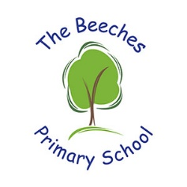
The Beeches Primary School
PSHE Curriculum – September 2026

Contents
Intent……………………………………………p2
Implementation……………………………..p2-3
Impact………………………………………….p4
Characters…………………………………….p5
EYFS……………………………………………..p6 - p16
Year 1……………………………………………p16 – p19
Year 2……………………………………………p20 – p23
Year 3……………………………………………p23 – p26
Year 4……………………………………………p27 – p30
Year 5……………………………………………p30 – p33
Year 6…………………………………………..p34 – p37
Progression by strand……………………..p38 – p40

Intent

At The Beeches Primary School, our PSHCE and RSHE curriculum sits at the heart of what we do. Many of our children begin their education with social, emotional and communication needs that are significantly lower than age-related expectations. Our curriculum is therefore deliberately designed to teach the knowledge, skills and attitudes pupils need to thrive, both now and in the future.

Our intent is to ensure every child:

- knows more, remembers more and understands more about how to lead safe, healthy and fulfilling lives
- develops the confidence, resilience and communication skills needed to build positive relationships
- understands their rights and responsibilities as valued members of a diverse community
- develops a strong sense of self-worth and identity
- is fully prepared to play a positive role in society, both in childhood and adulthood

To support this, our curriculum is structured around six school characters— Ravi Relationships, Safety Sam, Online Ollie, Wellbeing Willow, Worldwise Wren, and Growing Grace— each representing a key theme of RSHE. These characters provide continuity and a child-friendly identity for the curriculum, enabling pupils to relate to complex ideas through storytelling and scenario-based learning.

Every lesson begins with a learning question directed at the character, such as “How can we help Safety Sam understand which touches are safe?” This promotes purposeful learning and ensures children understand what they are trying to learn and why.

Lessons end with a plenary scenario, where pupils demonstrate their understanding by “teaching” the character how to respond to a situation. This strengthens retrieval, empowers children, and ensures they can apply knowledge in real-life contexts.

Our curriculum aims to support pupils in becoming caring, resilient, reflective and collaborative learners who contribute positively to school life, the community and the wider world.
Implementation

PSHCE and RSHE are taught through a clear, progressive and spiral curriculum from Reception to Year 6. Each year revisits the six core themes—Relationships, Safety, Online Safety, Wellbeing, Citizenship/World, and Growth—at increasing levels of depth, ensuring secure knowledge and progression.

Key features of implementation include:

1. A structured, whole-school progression map
The progression map we have developed outlines clear ‘to know’ statements, expanded detail, key vocabulary and learning questions for every year group. Knowledge builds incrementally from Early Years to Year 6, ensuring full coverage of statutory RSHE content.

2. The six RSHE characters
Each half-term centres on one character, supporting:

- consistency across the school
- memorable learning
- emotional connection to abstract concepts
- age-appropriate scaffolding for safeguarding themes

This shared structure ensures that, each half-term, the whole school learns about the same theme at an appropriate level.

3. Learning questions and plenary scenarios
- Every lesson begins with a learning question addressed to the character
- Every lesson ends with a plenary scenario where pupils apply their knowledge by advising the character

This consistent structure supports metacognition, retrieval practice and real-world application.

4. Alignment with statutory RSHE 2025 guidance
Our curriculum includes:

- Families and relationships
- Respectful relationships
- Friendships
- Being safe
- Consent and boundaries
- Online relationships and digital literacy
- Mental wellbeing
- Physical health and healthy lifestyles
- Puberty and the changing body
- Basic first aid
- Drug, alcohol and tobacco education (UKS2)
- Human reproduction (Year 5/6 only, non-graphic and age-appropriate)

5. Wider curriculum and whole-school ethos
RSHE is reinforced through:

- weekly assemblies
- British Values and SMSC
- pupil leadership roles
- safeguarding education
- whole-school events (Anti-Bullying Week, Online Safety Week, Mental Health Awareness Week)
- visits (e.g. the Life Education Bus)
- cross-curricular links (Science, Computing, PE)

6. Adaptive teaching
Lessons are accessible and scaffolded for pupils with SEND, EAL and children requiring emotional support. Vocabulary is explicitly taught, and clear structures help all children engage with sensitive themes safely.

Impact

By the end of each phase, children can talk confidently about how to keep themselves safe, healthy and emotionally well, and how to build and maintain respectful relationships.

In EYFS and Key Stage 1, children will:

- recognise their emotions and begin to self-regulate
- understand that their body belongs to them
- describe simple ways to stay safe offline and online
- build early friendships confidently
- understand the difference between kind/unkind behaviour
- begin to understand the diversity of families and communities

By the end of Key Stage 2, children will:

- understand how respectful relationships contribute to wellbeing
- recognise early signs of unhealthy or controlling behaviour
- manage conflict maturely and communicate assertively
- understand the physical and emotional changes of puberty
- know how to manage menstruation and bodily hygiene
- understand the basic science of human reproduction
- navigate online platforms safely and responsibly
- understand their rights, responsibilities and British Values
- demonstrate empathy, tolerance and emotional resilience
- challenge discrimination and stereotypes
- make informed choices about health, money and personal safety

Pupil outcomes

Our pupils leave The Beeches as:

- confident, articulate communicators
- emotionally literate young people capable of recognising and managing big feelings
- safe online users who know how to report concerns
- respectful, outward-looking citizens who value diversity
- resilient learners ready for secondary school
Most importantly, they leave us with the knowledge and confidence to navigate the world safely, form healthy relationships and make positive choices for their wellbeing.

Meet our characters:
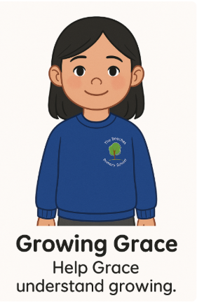 | 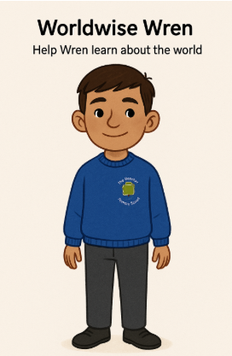 | 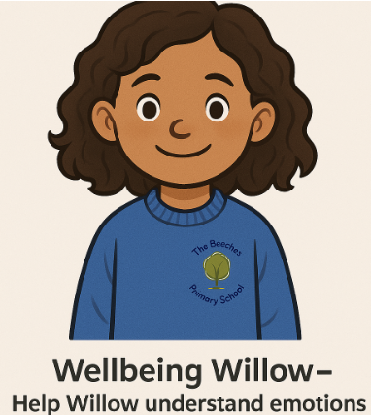
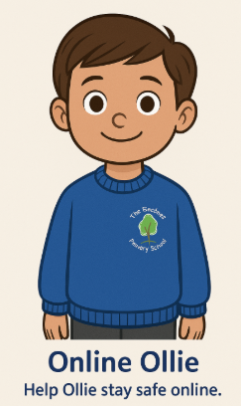 | 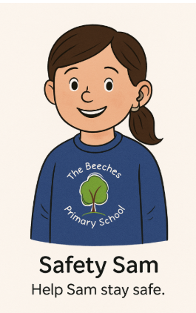 | 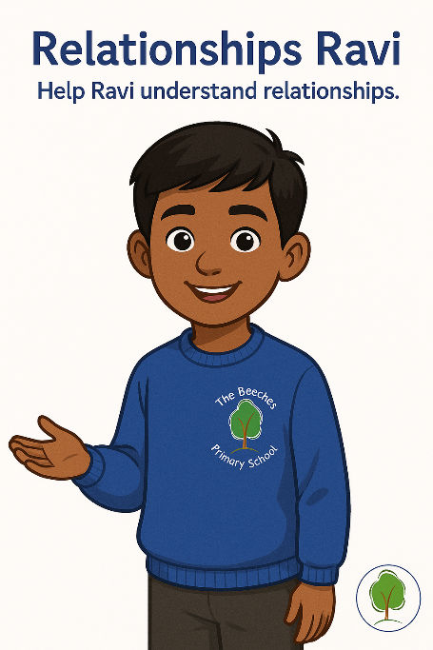

EYFS
Autumn 1 | Autumn 2 | Spring 1 | Spring 2 | Summer 1 | Summer 2
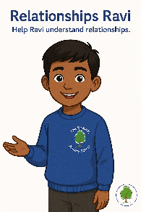
Knowledge: To know that families love and care for us (families help us with food, bedtime, cuddles, keeping us safe, looking after us when we are ill)  Learning Question: How will Ravi know that families help us feel loved and cared for?  Plenary Scenario: Ravi thinks families just cook and tidy. What else could you teach him about how families show love and care?  ___________________  Knowledge: To know that families can look different (single parents, two parents, same-sex parents, blended families, carers, adoptive families, grandparents)  Learning Question: How can we help Ravi see that all families are special in their own way?  Plenary Scenario: Ravi sees a family with two mums and says, “That’s not a real family.” What could you teach him?  ___________________  Knowledge: To know that friends help us feel happy and included (friends play with us, share, take turns, listen, invite us to join in)  Learning Question: How will Ravi know what makes a good friend?  Plenary Scenario: Ravi is playing alone and wants a friend. What could you teach him about joining in and being a good friend?  ___________________  Knowledge: To know that being kind helps us build good relationships (kind words, helping, sharing toys, comforting others, giving compliments)  Learning Question: How can we show Ravi what kindness looks like?  Plenary Scenario: Ravi grabs a toy and someone looks sad. What kind choice could you teach him to make instead?  Key Vocabulary: family, home, love, care, different, same, friend, kind, share, include | Knowledge: To know that bodies grow and change (babies → toddlers → children → adults; height, teeth falling out, hair growing)  Learning Question: How will Growing Grace learn that bodies change as we grow?  Plenary Scenario: Grace says she wants to stay the same forever. What can you teach her about growing?  ___________________  Knowledge: To know the names of basic body parts (head, arms, legs, hands, feet, tummy, elbows, knees — “private parts” may be introduced as “covered parts”)  Learning Question: How can we help Grace name different body parts?  Plenary Scenario: Grace points to her elbow and calls it her knee. How can you help her name her body parts?  ___________________  Knowledge: To know that babies need care to grow (feeding, changing nappies, cuddles, sleep, safety)  Learning Question: How will Grace learn what babies need to be looked after?  Plenary Scenario: Grace thinks babies can look after themselves. What should you teach her?  ___________________  Knowledge: To know that growing up can feel exciting or worrying (starting school, new experiences, class transitions, meeting new people)  Learning Question: How can we help Grace talk about how she feels when things change?  Plenary Scenario: Grace is worried about moving to Year 1. How can you help her talk about her feelings?  Key Vocabulary: grow, change, baby, child, adult, care, body, head, arms, legs, feelings | Knowledge: To know that we use devices to learn and play (tablets, phones, computers; used for games, videos, calls, information)  Learning Question: How can we help Online Ollie understand what devices are for?  Plenary Scenario: Ollie thinks tablets are only for games. What else can you teach him about devices?  ___________________  Knowledge: To know that we must ask before using someone else’s device (asking permission, waiting, respecting rules)  Learning Question: How will Online Ollie remember to ask before he uses a device?  Plenary Scenario: Ollie picks up someone else’s tablet without asking. What should he do instead?  ___________________  Knowledge: To know that some things online make us feel happy, and some things don’t (happy = songs/cartoons; unhappy = loud noises, scary images, rude messages)  Learning Question: How will we show Online Ollie what to do if something online feels wrong?  Plenary Scenario: Ollie sees something online that scares him. What should he do next?  ___________________  Knowledge: To know that grown-ups help us stay safe online (tell a grown-up immediately if something feels strange, scary, confusing)  Learning Question: How will Online Ollie know who to ask for help online?  Plenary Scenario: Ollie clicks something by accident and worries. Who should he tell?  Key Vocabulary: online, device, tablet, phone, ask, help, safe, adult, happy, worried | Knowledge: To know that our body belongs to us (body autonomy; we decide who touches us; noticing “comfortable” vs “uncomfortable” touch)  Learning Question: How will Safety Sam learn that his body belongs to him?  Plenary Scenario: Sam says someone held his hand when he didn’t want them to. What can you teach him about his body belonging to him?  ___________________  Knowledge: To know that we can say “no” to touch we don’t like (saying “no,” stepping back, telling an adult; examples: hugs, tickles, close contact)  Learning Question: How can we teach Safety Sam to say ‘no’ if something doesn’t feel right?  Plenary Scenario: Sam’s friend tickles him and he doesn’t like it. What should he do?  ___________________  Knowledge: To know who keeps us safe (trusted adults) (parents, carers, teachers, TAs, lunchtime staff; asking for help and telling them worries)  Learning Question: How will Safety Sam know who his safe adults are?  Plenary Scenario: Sam feels worried and doesn’t know who to tell. Who keeps him safe?  ___________________  Knowledge: To know that some secrets are unsafe to keep (safe secret = surprise; unsafe secret = makes us worried, scared, confused)  Learning Question: How will we help Safety Sam spot an unsafe secret?  Plenary Scenario: Someone tells Sam a secret that makes him feel funny inside. What should he do?  Key Vocabulary: safe, unsafe, body, private, no, stop, trusted adult, help, secret | Knowledge: To know that we all have feelings (happy, sad, scared, angry, excited — learning faces, voices, and body language)  Learning Question: How will Wellbeing Willow know what different feelings look like?  Plenary Scenario: Willow thinks grown-ups never feel sad. What can you teach her about feelings?  ___________________  Knowledge: To know that feelings change during the day (feelings come and go depending on events — morning vs afternoon feelings)  Learning Question: How can we help Willow understand that feelings come and go?  Plenary Scenario: Willow was happy earlier but annoyed now and thinks something is wrong. What could you tell her?  ___________________  Knowledge: To know simple ways to feel better (deep breaths, talking to an adult, quiet time, play, having a drink, asking for help)  Learning Question: How will Willow learn what helps her feel better?  Plenary Scenario: Willow is upset her tower fell down. What could help her feel better?  ___________________  Knowledge: To know that feeling lonely is something many people experience (everyone feels lonely sometimes; strategies include asking to play, joining in, talking to a teacher  Learning Question: How can we help Willow understand it’s okay to feel lonely sometimes?  Plenary Scenario: Willow feels lonely and thinks she’s the only one who feels that way. What can you teach her?  Key Vocabulary: happy, sad, angry, scared, worried, calm, lonely, help, talk, rest, feelings | Knowledge: To know that we are part of a community (class, school, local area, helpers such as teachers, cleaners, cooks, police, nurses)  Learning Question: How will Worldwise Wren learn what a community is?  Plenary Scenario: Wren says, “I only belong to myself.” How can you teach her about communities?  ___________________  Knowledge: To know that people have similarities and differences (skin tone, hair, families, food, languages, festivals, likes/dislikes, hobbies)  Learning Question: How can we show Wren that people can be different and still belong?  Plenary Scenario: Wren says someone’s lunch is “wrong” because it's different. What can you teach her about similarities and differences?  ___________________  Knowledge: To know that we can help others in small ways (tidying, holding doors, sharing, showing others what to do, asking “Do you want to play?”)  Learning Question: How will Wren learn how to help others?  Plenary Scenario: Wren sees someone struggling but walks past. How can you teach her about helping others?  ___________________  Knowledge: To know that rules help keep everyone safe (walking indoors, sharing, taking turns, lining up safely)  Learning Question: How will Wren understand why we have rules?  Plenary Scenario: Wren wants to run in the corridor. Why do we have rules?  Key Vocabulary: community, class, school, help, kind, differences, same, rules, belong, world

The EYFS Emotion Curriculum
Rationale – EYFS Emotions Curriculum
Big Feelings, Small Steps: Supporting Emotional Development in Early Years
At The Beeches Primary School, the EYFS Emotions Curriculum has been developed in direct response to Priority 5.2 of the School Improvement Plan: Big Feelings, Small Steps. This priority recognises that many of our youngest children arrive with limited emotional vocabulary and underdeveloped self-regulation skills, which can impact their readiness to learn, form relationships and engage meaningfully with the wider curriculum.
The rationale for this curriculum is grounded in the understanding that emotional literacy is foundational to all learning. By explicitly teaching children to recognise, name and manage their emotions, we support them to build resilience, develop self-awareness and begin the vital journey from co-regulation to self-regulation. This approach aligns with the SIP’s ambition to refine the EYFS PSED curriculum through structured, supportive teaching that prioritises emotional regulation and wellbeing
The introduction of Emotion Explorer Eli and Emotions Aisha provides a consistent, child-friendly framework through which children can explore complex feelings in a safe and relatable way. These characters allow emotional learning to be taught through story, role-play and real-life scenarios, enabling children to practise emotional strategies in a developmentally appropriate context. This supports the SIP’s focus on embedding emotional literacy through storytelling, modelling and guided discussion
The curriculum also strengthens provision through:
- Visual supports such as Feelings Check-In boards
- Emotion Coaching language used consistently by adults
- Safe spaces such as the “Cozy Corner”
- Explicit modelling of calming strategies and co-regulation
- Targeted CPD for staff on emotional development and regulation
These elements ensure fidelity and consistency in delivery and align with the plan to build staff confidence and expertise in supporting emotional dysregulation, trauma-informed practice and behaviour as communication
Furthermore, this curriculum is intentionally inclusive and responsive. It supports children with additional needs, communication difficulties, or social vulnerabilities by creating structured opportunities to express emotions safely, reducing anxiety and building confidence. It also strengthens transition into Year 1 by equipping children with the emotional language and self-regulation strategies they need to access more formal learning environments successfully.
Ultimately, this EYFS Emotions Curriculum ensures that emotional development is not implicit or incidental, but a carefully sequenced and explicitly taught strand of learning, giving every child the best possible foundation for lifelong emotional resilience, positive relationships and successful engagement with learning.
Meet Emotion Explorer Eli & Emotions Aisha
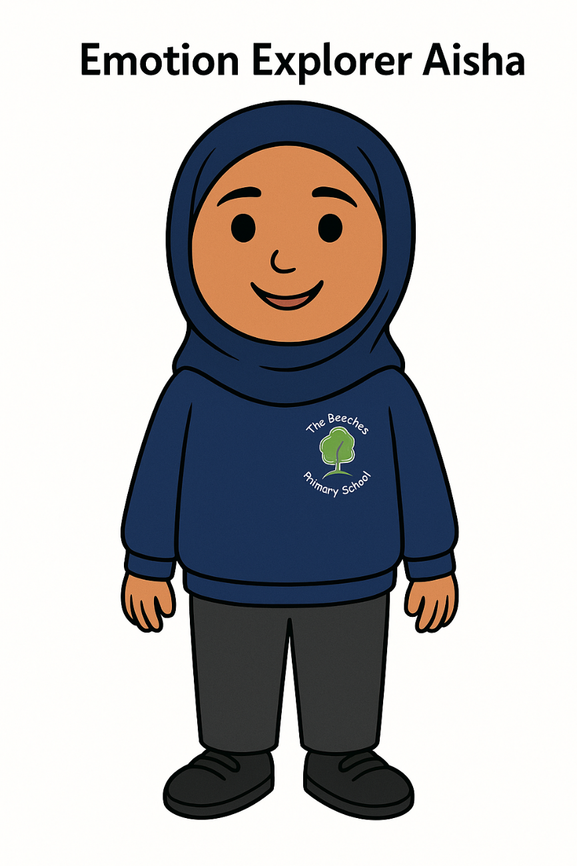 |  |  |  | 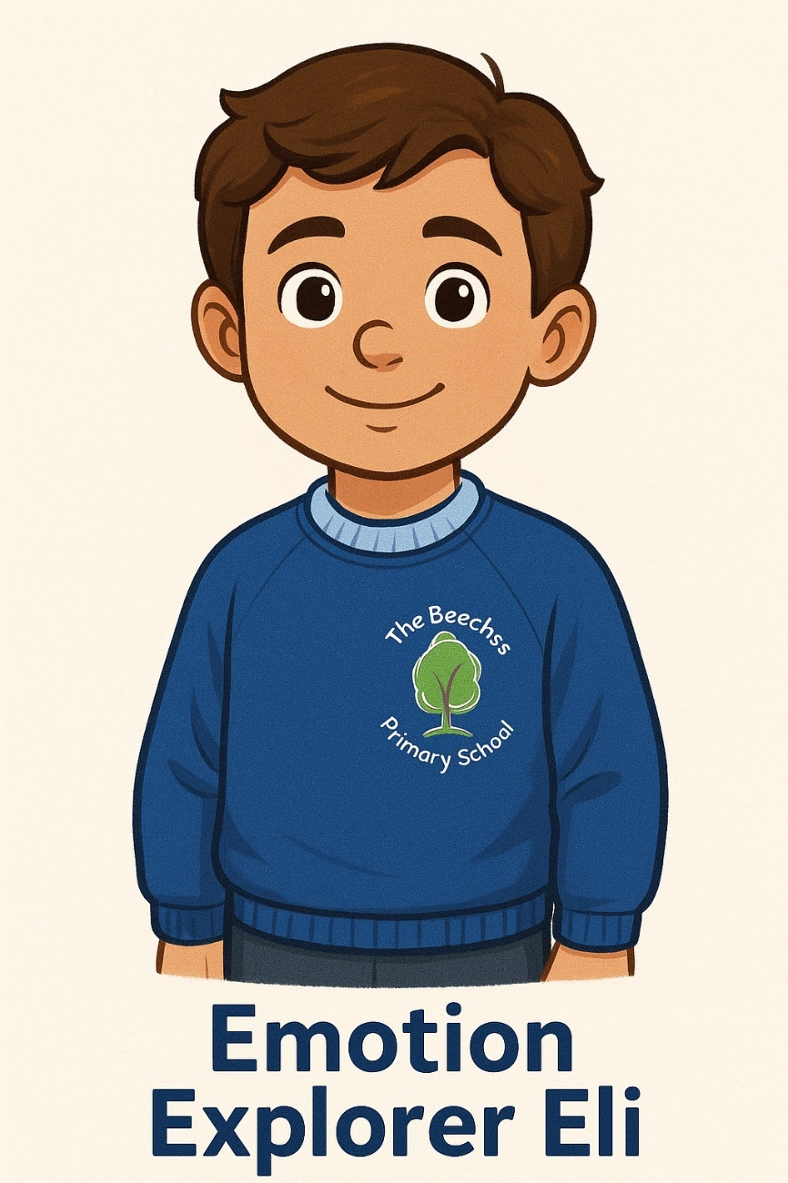
Meet Emotion Explorer Eli & Emotions Aisha
Emotion Explorer Eli and Emotions Aisha are the central characters used to deliver emotional learning across the EYFS Emotions Curriculum. They provide a consistent, safe and relatable framework through which children explore, understand and practise managing their feelings.
Eli and Aisha act as emotional guides. They experience a wide range of feelings that mirror those children commonly encounter in early childhood, such as happiness, sadness, anger, worry, frustration and pride. Through their stories, scenarios and challenges, children are able to observe emotional situations at a safe distance and discuss how the characters should respond, reducing anxiety and increasing emotional understanding.
How the characters are used in practice:
- Each half-term is led by either Eli or Aisha, with a specific emotion focus.
- Every lesson begins with a learning question directed at the character (e.g. How will Eli calm down when he feels angry?), encouraging purpose and empathy.
- Children explore the character’s feelings through storytelling, role-play, puppetry and visual prompts.
- Lessons end with a plenary scenario, where children teach the character what strategies to use.
- Visuals of Eli and Aisha are displayed in the classroom and calm areas to support emotional language and recall.
Staff model emotional language using the characters, reinforcing phrases such as:
“What would Eli do if he felt this way?”
“How could Aisha calm her body?”
Why characters support emotional development
Using Eli and Aisha supports:
- Emotional safety and distancing (children explore emotions through the character first)
- Development of empathy and perspective-taking
- Increased emotional vocabulary
- Consistent co-regulation language
- Confidence to talk about big feelings
Through these characters, emotional learning becomes structured, memorable and child-centred. Children develop a growing sense that emotions are normal, manageable and safe to talk about, supporting the transition from adult-supported regulation to independent emotional control.
Half Term & Emotion | Knowledge Focus | Learning Question | Plenary Scenario |  | Core Skills | Strategies | Suggested Texts | Key Vocabulary
Autumn 1 – Happiness (Eli) | To know that happiness is a feeling we all experience (recognising signs of happiness in body and face) | How will Eli recognise when he is feeling happy? | Eli feels funny inside and doesn’t know why. How can we explain happiness to him? |  | Recognising happiness; expressing joy | Celebrate achievements; mirror happy expressions | The Colour Monster; Happy; Today I Feel  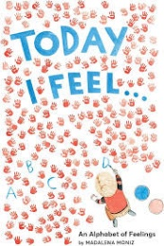 | happy, joy, excited
Autumn 2 – Sadness (Eli) | To know that sadness is normal and will pass | How will Eli learn that feeling sad is okay? | Eli feels sad as his friend didn’t play. What could help him? |  | Naming sadness; seeking comfort | Quiet corner; drawings; role-play | The Sad Book; When I Feel Sad  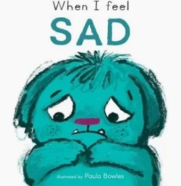 | sad, upset, comfort
Spring 1 – Anger (Eli) | To know that anger is a strong feeling that can be managed | How will Eli learn to manage his angry feelings safely? | Eli wants to shout. What calming strategy should he use? |  | Identify anger; calming self | Breathing; counting; stress toy | When I Feel Angry; Anh’s Anger  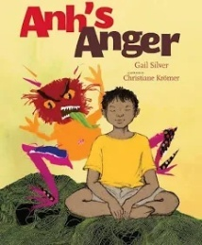 | angry, calm, control
Spring 2 – Worry (Aisha) | To know that worry is a feeling and talking helps | How will Aisha know what to do when she feels worried? | Aisha feels scared but doesn’t speak. What should she do? |  | Recognising worry; reassurance | Worry box; safe adult talk | Silly Billy; Ruby’s Worry  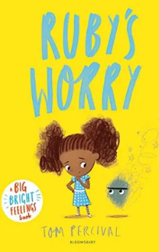 | worry, nervous, reassurance
Summer 1 – Frustration (Aisha) | To know frustration happens when tasks feel difficult | How will Aisha learn to keep trying when frustrated? | Aisha can’t zip coat and wants to give up. What now? |  | Perseverance; patience | Encourage retrying; praise effort | The Dot; Rosie Revere  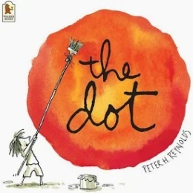 | frustrated, effort
Summer 2 – Pride & Belonging (Both) | To know pride comes from trying and achieving | How will Eli and Aisha understand pride? | Aisha is proud but shy. What should she remember? |  | Self-reflection; confidence | Peer praise; display work | I Like Myself; The Invisible Boy  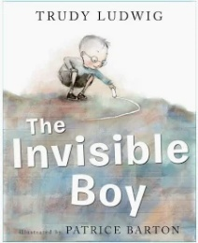 | proud, belonging

Year 1
Autumn 1 | Autumn 2 | Spring 1 | Spring 2 | Summer 1 | Summer 2
Knowledge: To know that families provide love, safety and stability  (children learn families help with food, routines, comfort, protection, problem-solving, and reassurance)  Learning Question: How will Ravi know what families do to keep us safe and cared for?  Plenary Scenario: Ravi thinks only some families show love. What could you teach him about how families care for children?  ___________________  Knowledge: To know that families can be similar or different to our own  (children explore examples: siblings/no siblings, two mums/two dads, adoptive families, living with grandparents, blended families)  Learning Question: How can we help Ravi understand that all families are important, even if they look different?  Plenary Scenario: Ravi says a family different from his “doesn’t count.” What should you teach him?  ___________________  Knowledge: To know the qualities of a good friend  (kindness, honesty, taking turns, sharing, listening, inviting others to play)  Learning Question: How can we help Ravi spot the qualities that make someone a good friend?  Plenary Scenario: Ravi isn’t sure if someone is being a good friend. What signs can you teach him to look for?  ___________________  Knowledge: To know what makes a relationship positive  (positive behaviours: friendly words, gentle hands, helping, fairness; negative behaviours: snatching, shouting, excluding)  Learning Question: How will Ravi know which behaviours make relationships feel positive?  Plenary Scenario: Ravi sees someone shouting at a friend. What could you teach him about positive and negative behaviours?  Key Vocabulary: family, relationships, safe, love, care, friend, kind, honest, fair, take turns, include | Knowledge: To know that as we grow, our bodies and abilities change  (growing taller, becoming stronger, learning new skills, losing baby teeth)  Learning Question: How will Grace learn what changes as we grow?  Plenary Scenario: Grace wonders why she is growing taller. What can you teach her?  ___________________  Knowledge: To know the differences between children and adults  (adults make decisions, work, care for children; children need support and supervision)  Learning Question: How can we help Grace understand how children and adults are different?  Plenary Scenario: Grace thinks children and adults are the same. What differences can you teach her?  ___________________  Knowledge: To know how to keep our bodies healthy  (washing hands, brushing teeth, eating fruit/veg, exercise, sleep)  Learning Question: How will Grace learn how to take care of her body every day?  Plenary Scenario: Grace forgets how to keep clean and healthy. What should she remember?  ___________________  Knowledge: To know that changes can feel exciting or worrying and that it is okay to talk about feelings  (moving to Year 2, new routines, new teachers)  Learning Question: How can we help Grace talk about how she feels about changes?  Plenary Scenario: Grace feels nervous about Year 2. What could she do to share her feelings?  Key Vocabulary: grow, change, adult, child, teeth, healthy, exercise, hygiene, worried, excited | Knowledge: To know that information online can be true or untrue  (children learn that pictures, videos and messages online aren’t always real)  Learning Question: How can we help Ollie understand that some things online can trick us?  Plenary Scenario: Ollie believes everything he sees online. What would you teach him?  ___________________  Knowledge: To know how to behave kindly online  (positive behaviours: using kind words in games, not sending unkind emojis/messages, asking before taking photos)  Learning Question: How will Ollie know how to be kind to others online?  Plenary Scenario: Ollie sends a message in a game without thinking. How can he check it’s kind?  ___________________  Knowledge: To know what to do if something online makes us feel worried or confused  (stop using the device, tell an adult, turn off the screen)  Learning Question: How can we help Ollie decide what to do when something online doesn’t feel right?  Plenary Scenario: Ollie sees something confusing online. What should he do?  ___________________  Knowledge: To know that we keep personal information private  (no sharing of name, school, address, passwords, photos without adult support  Learning Question: How will Ollie know which information he should never share online?  Plenary Scenario: Ollie is asked to share his name online. What should he say?  Key Vocabulary: online, real, not real, kind, message, private information, worry, confused, help | Knowledge: To know the differences between appropriate and inappropriate touch  (hugs, hand-holding with permission vs hitting, grabbing, touching private areas)  Learning Question: How can we help Safety Sam understand which touches are okay and which are not?  Plenary Scenario: Sam is unsure if a touch from another child is okay. What should she think about?  ___________________  Knowledge: To know that private body parts should not be touched by others (introducing correct terms: penis, vagina, bottom, chest; “private = covered by underwear”)  Learning Question: How will Safety Sam know which parts of her body are private?  Plenary Scenario: Sam forgets which body parts are private. How can you remind her?  ___________________  Knowledge: To know what to do if something feels unsafe  (steps: say no, move away, tell a trusted adult, keep telling until someone listens)  Learning Question: How can we teach Sam exactly what to do when something feels wrong?  Plenary Scenario: Sam feels unsafe but doesn’t know what to do. What steps should she take?  ___________________  Knowledge: To know the difference between a secret and a surprise  (surprise = safe, will be told; secret that feels scary, uncomfortable, or confusing = unsafe)  Learning Question: How will Sam know which secrets she should not keep?  Plenary Scenario: Someone tells Sam a secret that makes her uncomfortable. What must she do?  Key Vocabulary: private, safe, unsafe, surprise, secret, trusted adult, permission, no, stop | Knowledge: To know that our bodies and minds can feel different emotions  (identifying: proud, embarrassed, frustrated, shy, excited)  Learning Question: How will Willow learn to name and notice different feelings in her body?  Plenary Scenario: Willow feels embarrassed but doesn’t know the word. How can you help her understand her feelings?  ___________________  Knowledge: To know simple strategies to manage emotions  (breathing, counting to 10, talking, brain breaks, movement, asking for help)  Learning Question: How can we help Willow learn ways to manage big feelings?  Plenary Scenario: Willow gets upset quickly. Which strategies could you teach her?  ___________________  Knowledge: To know that talking about worries helps us feel better  (who we can talk to: teacher, trusted adult, friends, family)  Learning Question: Who can help Willow when she has a worry, and how will she know?  Plenary Scenario: Willow has a worry but doesn’t want to tell anyone. Who can she talk to?  ___________________  Knowledge: To know what bullying means  (someone being unkind repeatedly on purpose; including not letting someone join in)  Learning Question: How can we help Willow recognise when something becomes bullying?  Plenary Scenario: Willow sees someone being repeatedly unkind. How can she tell it might be bullying?  Key Vocabulary: emotion, proud, embarrassed, frustrated, calm, breathing, worry, talk, bullying, help | Knowledge: To know what a community is and who helps us  (teachers, office staff, cleaners, police, nurses, shop workers; children explore roles)  Learning Question: How will Wren learn who helps our community and what they do?  Plenary Scenario: Wren doesn’t know who helps in the community. Who could you teach him about?  ___________________  Knowledge: To know that people have different strengths and interests  (sports, reading, music, building, helping others; differences make communities stronger)  Learning Question: How can we help Wren understand that everyone is good at different things?  Plenary Scenario: Wren feels sad that he isn’t good at everything. What should you teach him about strengths?  ___________________  Knowledge: To know the basics of money  (coins, notes, we use money to buy things; some things cost more/less)  Learning Question: How will Wren learn what money is used for?  Plenary Scenario: Wren wonders why we need money. What will you teach him?  ___________________  Knowledge: To know that we take care of shared places  (litter picking, recycling, looking after school grounds, not wasting materials)  Learning Question: How can we help Wren understand how to look after our world?  Plenary Scenario: Wren wants to drop rubbish outside. What could you teach him about caring for shared places?  Key Vocabulary: community, helper, strength, interest, money, coins, notes, recycle, care, world

Year 2
Autumn 1 | Autumn 2 | Spring 1 | Spring 2 | Summer 1 | Summer 2
Knowledge: To know that families provide love and support even when they face challenges  (arguments, busy routines, changes such as a new baby; families solve problems together)  Learning Question: How can we help Ravi understand that families care for each other even when things are tricky?  Plenary Scenario: Ravi thinks families stop loving each other when things get difficult. What would you teach him?  ___________________  Knowledge: To know that there are different types of families and all deserve respect  (children learn to use positive language about same-sex parents, stepfamilies, foster families, carers)  Learning Question: How will Ravi learn to show respect to all families?  Plenary Scenario: Ravi meets a family different from his and feels unsure. What could you say to help?  ___________________  Knowledge: To know how to build and maintain friendships  (saying sorry, taking responsibility, checking in with friends, understanding how actions affect feelings)  Learning Question: How will Ravi learn to look after his friendships?  Plenary Scenario: Ravi falls out with a friend. How can he fix it?  ___________________  Knowledge: To know that teasing and name-calling can hurt feelings and damage relationships  (difference between playful joking and unkind words; understanding emotional impact)  Learning Question: How can we help Ravi recognise when teasing stops being fun?  Plenary Scenario: Ravi laughs at someone’s name and they look sad. What should he learn?  Key Vocabulary: family, respect, support, challenge, friendship, include, apology, tease, unkind, feelings | Knowledge: To know that bodies change as we grow and that this is normal  (height, strength, hair growth, skills improving, less dependence on adults)  Learning Question: How will Grace learn what changes are normal as we get older?  Plenary Scenario: Grace worries about growing taller. What could you teach her?  ___________________  Knowledge: To know that we develop new abilities as we grow  (tying laces, reading, writing, helping at home, being more independent)  Learning Question: How can we help Grace recognise the new skills she is learning?  Plenary Scenario: Grace is proud of a new skill. How can she notice her progress?  ___________________  Knowledge: To know the importance of hygiene routines  (teeth brushing, handwashing, bathing, hair care — understanding germs and illness prevention)  Learning Question: How will Grace learn the hygiene routines that keep her body healthy?  Plenary Scenario: Grace forgets to brush her teeth. Why is this important?  ___________________  Knowledge: To know that changes can bring mixed feelings and that talking helps  (moving to a new class, friendships changing, new teachers)  Learning Question: Who can Grace talk to when changes feel confusing or worrying?  Plenary Scenario: Grace feels nervous about a new teacher. What should she do?  Key Vocabulary: grow, change, independence, hygiene, germs, routine, feelings, support | Knowledge: To know that people online may not be who they say they are  (introducing the idea of anonymity; avatars vs real people; games with chat functions)  Learning Question: How will Ollie learn that someone online might not be real?  Plenary Scenario: Ollie thinks everyone online is his friend. What should you teach him?  ___________________  Knowledge: To know how to behave safely when using devices  (covering webcam, checking with an adult before clicking links, using safe search tools)  Learning Question: How can we help Ollie know the rules for safe device use?  Plenary Scenario: Ollie doesn’t know if he should click a pop-up. What’s the safe choice?  ___________________  Knowledge: To know that online messages should be kind and respectful  (no sharing hurtful emojis, no teasing in games, thinking before posting)  Learning Question: What will help Ollie send kind messages online?  Plenary Scenario: Ollie wants to send a joke message. How can he check it’s kind?  ___________________  Knowledge: To know what personal information is and why we protect it  (examples: full name, school name, address, photos, uniform — all protected)  Learning Question: How will Ollie know what is personal information that he must not share?  Plenary Scenario: Ollie is asked to share his school name online. What should he say?  Key Vocabulary: online, stranger, avatar, message, safe search, personal information, click, kind, respect | Knowledge: To know that everyone has a right to feel safe  (children explore safe/unsafe places, feelings that signal danger — tummy aches, wanting to run away)  Learning Question: How will Safety Sam know what feeling safe or unsafe feels like?  Plenary Scenario: Sam feels unsafe but doesn’t know why. How can she recognise unsafe feelings?  ___________________  Knowledge: To know the PANTS rule and correct names for private parts  (penis, vulva, vagina, bottom, nipples; underwear rule reinforces privacy boundaries)  Learning Question: How can we help Sam remember which parts are private?  Plenary Scenario: Sam forgets the PANTS rule. How could you help her remember?  ___________________  Knowledge: To know strategies to stay safe in everyday situations  (not opening doors to strangers, staying close to an adult in public, safe road behaviour)  Learning Question: How will Sam know what to do to stay safe each day?  Plenary Scenario: Sam walks to the door when someone knocks. What should she do instead?  ___________________  Knowledge: To know how to report worries and keep telling until someone listens  (trusted adult list; explaining persistence — especially important for safeguarding)  Learning Question: How can Sam learn to tell and tell again until she gets help?  Plenary Scenario: Sam reports a worry but no one listens. What should she do next?  Key Vocabulary: safe, unsafe, private, penis, vulva, vagina, trusted adult, danger, PANTS, report | Knowledge: To know that everyone experiences a range of emotions  (anger, fear, excitement, disappointment, jealousy — normalising all emotions)  Learning Question: How can we help Willow understand that all feelings are okay?  Plenary Scenario: Willow feels jealous but doesn’t recognise it. How could you help her?  ___________________  Knowledge: To know how our actions affect the feelings of others  (tone of voice, facial expression, kind/unkind choices, including/excluding)  Learning Question: How will Willow learn to notice how her actions make others feel?  Plenary Scenario: Willow shouts when she’s frustrated. What could she try instead?  ___________________  Knowledge: To know healthy ways to manage worries and big feelings  (breathing, journaling/drawing feelings, speaking to an adult, taking breaks)  Learning Question: How will Willow know what to do when her feelings feel too big?  Plenary Scenario: Willow has a worry but hides it. Who could she talk to?  ___________________  Knowledge: To know what bullying is and what to do  (repeated unkindness; telling a trusted adult immediately; not blaming themselves)  Learning Question: How will Willow know when to tell an adult about bullying?  Plenary Scenario: Willow sees someone being repeatedly unkind. What should she do?  Key Vocabulary: emotion, jealous, disappointed, worried, calm, choices, impact, bullying, support | Knowledge: To know that communities include people with different roles  (teachers, doctors, shop workers, carers, councillors, volunteers — all helping society work)  Learning Question: How will Wren learn about the roles people play in the community?  Plenary Scenario: Wren thinks only teachers help the community. Who else could he learn about?  ___________________  Knowledge: To know that everyone has rights and responsibilities  (right to be safe, right to be heard, responsibility to follow rules and be kind)  Learning Question: How can Wren learn the difference between rights and responsibilities?  Plenary Scenario: Wren wants all the rights but none of the responsibilities. What would you teach him?  ___________________  Knowledge: To know how to look after the environment  (recycling, saving water, turning off lights, caring for animals/plants, reducing waste)  Learning Question: How will Wren learn ways to take care of the environment?  Plenary Scenario: Wren leaves litter on the playground. What should he do?  ___________________  Knowledge: To know simple money concepts: earning, storing, spending  (pocket money, saving jars, making choices about spending, items having different value)  Learning Question: How can we help Wren learn how people use money?  Plenary Scenario: Wren spends money without thinking. How could he learn to make choices?  Key Vocabulary: community, role, responsibility, right, rule, recycle, environment, money, earn, save

Year 3
Autumn 1 | Autumn 2 | Spring 1 | Spring 2 | Summer 1 | Summer 2
Knowledge: To know the importance of showing respect in families and friendships  (respecting differences in routines, beliefs, rules; treating others fairly and listening when they speak)  Learning Question: How can we help Ravi understand why respect is important in relationships?  Plenary Scenario: Ravi interrupts someone because he thinks his idea is better. What should he learn about respect?  ___________________  Knowledge: To know how to recognise healthy and unhealthy friendship behaviours  (healthy: encouragement, fairness, honesty; unhealthy: controlling behaviour, excluding, putting down)  Learning Question: How will Ravi learn to tell when a friendship is healthy or unhealthy?  Plenary Scenario: Ravi sees a friend being too controlling. How can he tell if it’s unhealthy behaviour?  ___________________  Knowledge: To know how actions and words affect relationships  (tone of voice, facial expressions, sarcasm, kindness; how behaviour can strengthen or hurt relationships)  Learning Question: How will Ravi learn how his behaviour affects others?  Plenary Scenario: Ravi uses a sharp tone and upsets someone. What should he reflect on?  ___________________  Knowledge: To know how to resolve conflict positively  (strategies: listening, compromise, apologising, using calm words, finding solutions)  Learning Question: How can we help Ravi learn ways to fix problems with friends?  Plenary Scenario: Ravi and a friend argue over a game. How could he resolve it calmly?  Key Vocabulary: respect, healthy, unhealthy, friendship, behaviour, conflict, compromise, honesty, fairness | Knowledge: To know that bodies grow and change as part of childhood (height, strength, new skills, teeth changes, emotional development)  Learning Question: How will Grace learn what early changes might happen as she grows?  Plenary Scenario: Grace notices her body feels warmer during play and feels embarrassed, what should she do?  ___________________  Knowledge: To know that everyone grows at different rates  (differences in height, body shape, and development; no “right” time to grow)  Learning Question: How can we help Grace understand that growing is different for everyone?  Plenary Scenario: Grace is growing more slowly than her friends. How should she think about this?  ___________________  Knowledge: To know how to maintain good hygiene as our bodies change  (washing, deodorant introduction, clean clothes, brushing teeth, cleaning hair)  Learning Question: How will Grace learn the routines that help keep her body clean?  Plenary Scenario: Grace forgets to use deodorant or wash regularly. Why is this important?  ___________________  Knowledge: To know that feelings can change during growth and big transitions  (friendships shifting, becoming more independent, mixed emotions about change)  Learning Question: How can we help Grace express how she feels about growing up?  Plenary Scenario: Grace feels worried about getting older. Who can she talk to?  Key Vocabulary:, sweat, growth spurt, hygiene, deodorant, change, transition, difference, body care | Knowledge: To know how to stay safe when communicating online  (only speaking to people they know in real life; checking before chatting in games; risks of strangers)  Learning Question: How will Ollie learn safe ways to talk to people online?  Plenary Scenario: Ollie gets a message from someone he doesn’t know online. What should he do?  ___________________  Knowledge: To know that online content can be edited, filtered, or fake  (pictures that are changed, fake profiles, misleading videos)  Learning Question: How can we help Ollie understand that online things might look real but not be?  Plenary Scenario: Ollie sees a picture that looks real but feels strange. How could he check if it’s fake?  ___________________  Knowledge: To know what cyberbullying is and what to do  (repeated unkind messages, excluding online, mean comments in chats; report, block, tell an adult)  Learning Question: How will Ollie recognise and respond to cyberbullying?  Plenary Scenario: Ollie receives an unkind message during a game. What are his steps?  ___________________  Knowledge: To know the importance of screen time balance  (healthy habits: breaks, outdoor play, avoiding long stretches on devices)  Learning Question: How can we help Ollie learn to balance digital time with other activities?  Plenary Scenario: Ollie keeps playing without breaks. What should he do to stay healthy?  Key Vocabulary: online safety, stranger, edit, fake, cyberbullying, message, block, report, screen time, balance | Knowledge: To know that we have the right to personal boundaries  (saying no, choosing who we hug, recognising “red flag” behaviours)  Learning Question: How will Sam learn to set safe personal boundaries?  Plenary Scenario: Sam feels uncomfortable when someone stands too close. What could she do?  ___________________  Knowledge: To know how to recognise and react to peer pressure  (feeling pushed, someone trying to make us break rules, “if you’re my friend…” persuasion)  Learning Question: How can we help Sam notice when someone is pressuring her?  Plenary Scenario: Sam is encouraged to break a rule “to fit in.” What should she do?  ___________________  Knowledge: To know the difference between secrets and surprises and why unsafe secrets must be told  (secrets that cause worry, fear, shame, confusion should be shared with a trusted adult)  Learning Question: How will Sam learn which secrets she must never keep?  Plenary Scenario: Sam is asked to keep a secret that makes her uneasy. What should she remember?  ___________________  Knowledge: To know basic first aid responses for common injuries  (what to do for small cuts, grazes and nosebleeds; staying calm; not panicking; seeking adult help; understanding that their role is to keep themselves safe and get help rather than treat serious injuries)  Learning Question: How can we teach Safety Sam what to do if someone gets hurt??  Plenary Scenario: Sam sees a child fall over and start bleeding from their knee. What steps should she take to help safely?  Key Vocabulary: boundary, privacy, pressure, unsafe secret, trusted adult, consent, choice, red flag, safe place | Knowledge: To know how to recognise physical signs of emotions  (tight chest, fast heartbeat, butterflies, sweaty palms, fidgeting — linking body to feelings)  Learning Question: How will Willow learn to notice how her body feels when she has strong emotions?  Plenary Scenario: Willow feels her heart beating fast when she’s worried. What does that mean?  ___________________  Knowledge: To know a range of strategies for emotional regulation  (grounding, counting, movement breaks, positive self-talk, talking to a trusted adult)  Learning Question: What strategies can Willow learn to manage big feelings?  Plenary Scenario: Willow feels overwhelmed in class. What strategy could she use?  ___________________  Knowledge: To know what mental wellbeing means  (feeling good about oneself, connection, purpose, rest, balance)  Learning Question: How will Willow understand what helps her mental wellbeing?  Plenary Scenario: Willow feels low and doesn’t know why. Who could she talk to?  ___________________  Knowledge: To know that life changes can affect emotions  (moving house, new siblings, friendship changes; it’s normal to feel mixed emotions)  Learning Question: How can we help Willow understand that change can bring different feelings?  Plenary Scenario: Willow is moving to a new club and feels nervous. What can she do?  Key Vocabulary: emotion, anxious, overwhelmed, regulate, strategy, wellbeing, self-talk, grounding, change | Knowledge: To know why rules and laws are important  (keeping people safe, fairness, protecting rights; difference between school rules and community laws)  Learning Question: How can Wren learn why we have rules and laws?  Plenary Scenario: Wren thinks rules are just to stop fun. What could he learn about laws?  ___________________  Knowledge: To know how communities work together  (volunteers, local councils, charities, neighbourhood support groups)  Learning Question: How will Wren understand how people work together to make communities better?  Plenary Scenario: Wren sees volunteers helping at school. What does this show him about teamwork?  ___________________  Knowledge: To know what diversity means  (differences in culture, ethnicity, language, religion, families, interests; valuing differences)  Learning Question: How can we help Wren understand the importance of diversity?  Plenary Scenario: Wren meets someone from a different culture. What should he remember?  ___________________  Knowledge: To know the importance of making informed choices about spending money  (saving vs spending, value for money, comparing items)  Learning Question: How will Wren learn to make smart choices with money?  Plenary Scenario: Wren wants to buy something expensive. What should he consider?  Key Vocabulary: law, rule, community, diversity, culture, religion, charity, value, spending, saving

Year 4
Autumn 1 | Autumn 2 | Spring 1 | Spring 2 | Summer 1 | Summer 2
Knowledge: To know how to build healthy, respectful relationships  (respecting boundaries, active listening, calm communication, valuing others’ opinions, resolving disagreements fairly  Learning Question: How can we help Ravi understand what makes a relationship respectful?  Plenary Scenario: Ravi feels upset because his friendship feels different. What should he know?  ___________________  Knowledge: To know how to recognise early signs of unhealthy relationships  (being bossy, excluding others, controlling behaviour, guilt-tripping, making someone feel small)  Learning Question: How will Ravi learn to spot the signs that a relationship may not be healthy?  Plenary Scenario: Ravi’s friend keeps bossing him around. What should he notice?  ___________________  Knowledge: To know that relationships can change over time  (friendships developing, drifting apart, new friendships forming; linked feelings)  Learning Question: How can we help Ravi understand that changes in friendships are normal?  Plenary Scenario: Ravi doesn’t know how to solve a disagreement. What could he do?  ___________________  Knowledge: To know how and when to ask for help with relationship problems  (talking to trusted adults when problems feel too big to solve alone)  Learning Question: How will Ravi know when it is time to seek help?  Plenary Scenario: Ravi feels he needs help but is unsure. Who should he talk to?  Key Vocabulary: respect, boundary, healthy, unhealthy, change, conflict, communication, support, trust | Knowledge: To know that bodies grow and change at different times  (height, strength, body shapes changing as part of normal development)  Learning Question: How will Grace learn that bodies change as we grow?  Plenary Scenario: Grace notices her body changing slightly and feels confused. What should she know?  ___________________  Knowledge: To know how to care for the body as it grows  (daily washing, deodorant introduction, clean clothes, oral hygiene)  Learning Question: How can we help Grace learn how to take care of her body?  Plenary Scenario: Grace forgets to wash regularly. Why is hygiene important?  ___________________  Knowledge: To know that growing up brings emotional changes too  (mood changes, sensitivity, increased independence)  Learning Question: How will Grace learn to understand her changing feelings?  Plenary Scenario: Grace feels emotional and doesn’t understand why. What should she realise?  ___________________  Knowledge: To know that everyone develops at their own pace  (no comparison; differences are normal)  Learning Question: How can we help Grace feel confident about her own development?  Plenary Scenario: Grace compares herself to others. How can she stay confident?  Key Vocabulary: growth, development, hygiene, emotions, confidence, independence, change, routine | Knowledge: To know how to protect personal information online  (photos, name, location, school, passwords)  Learning Question: How can we help Ollie keep his information safe online?  Plenary Scenario: Ollie is asked for personal information. What should he do?  ___________________  Knowledge: To know that online behaviour has real-life consequences  (posts can be saved, shared, screen-recorded)  Learning Question: How will Ollie learn to think before posting?  Plenary Scenario: Ollie posts something without thinking. What should he reflect on?  ___________________  Knowledge: To know the risks of online communication with strangers  Learning Question: How will Ollie stay safe when talking online?  Plenary Scenario: Ollie chats with someone he doesn’t know. What is the safe choice?  ___________________  Knowledge: To know how to report inappropriate online content  (block, report, tell a trusted adult)  Learning Question: How will Ollie know what to do if something online feels wrong?  Plenary Scenario: Ollie sees something online that upsets him. What should he do next?  Key Vocabulary: privacy, digital footprint, consequence, profile, stranger, report, block, harmful content, safety | Knowledge: To know how to stay safe in risky situations  (road safety, water safety, peer pressure, unsafe dares)  Learning Question: How will Safety Sam learn to make safe choices?  Plenary Scenario: Sam feels pressured to try something risky. What should she do?  ___________________  Knowledge: To know that consent means clear permission  (agreeing freely, not forced, can change your mind)  Learning Question: How will Sam understand what consent means?  Plenary Scenario: Sam isn’t sure if she wants physical contact. How can she show consent?  ___________________  Knowledge: To know how to recognise grooming behaviours (child-friendly)  (excessive attention, gifts, secrecy, making someone feel “special” in unsafe ways)  Learning Question: How can Sam notice when behaviour doesn’t feel right?  Plenary Scenario: Someone gives Sam gifts and says not to tell. What should she think?  ___________________  Knowledge: To know how to respond safely in an emergency situation  (understanding what an emergency is; calling 999; knowing what to say: location, what happened, who is hurt; staying calm and not putting themselves in danger)  Learning Question: How will Safety Sam know what to do in an emergency?  Plenary Scenario: Sam sees someone collapse on the playground. What should she do first and who should she tell?  Key Vocabulary: risk, consent, permission, grooming (simplified), unsafe, pressure, boundary, stranger | Knowledge: To know how to recognise worry, stress and emotional overload  (physical signs: headaches, fast heartbeat, difficulty concentrating, irritability)  Learning Question: How will Willow learn to spot when she is becoming stressed or overwhelmed?  Plenary Scenario: Willow feels overwhelmed and snappy. What does that tell her?  ___________________  Knowledge: To know strategies for building resilience  (positive self-talk, trying again, practising problem solving, asking for help, celebrating effort)  Learning Question: How can Willow learn to become more resilient?  Plenary Scenario: Willow wants to give up quickly. How can she build resilience?  ___________________  Knowledge: To know what self-esteem is and how to develop it  (positive identity, recognising achievements, accepting mistakes, valuing strengths)  Learning Question: How will Willow learn to feel good about who she is?  Plenary Scenario: Willow compares herself negatively. What should she remember?  ___________________  Knowledge: To know how relationships impact emotional wellbeing  (supportive vs draining relationships; how friends help, how unkindness hurts)  Learning Question: How can we help Willow understand the link between relationships and wellbeing?  Plenary Scenario: Willow feels hurt by a friend. What could she do?  Key Vocabulary: stress, resilience, perseverance, self-esteem, achievement, identity, overwhelm, wellbeing | Knowledge: To know the importance of respecting people from different backgrounds  (ethnicities, religions, beliefs, families, languages; valuing uniqueness)  Learning Question: How will Wren learn why respecting differences matters?  Plenary Scenario: Wren meets someone different from him. What should he remember about respect?  ___________________  Knowledge: To know how democratic decisions are made  (voting, debating, fairness; comparing class votes to national elections  Learning Question: How can we help Wren understand democracy?  Plenary Scenario: Wren votes without listening to others. Why is democracy important?  ___________________  Knowledge: To know how to be socially responsible  (caring for shared spaces, being aware of others’ needs, positive community participation)  Learning Question: How will Wren learn how he can contribute to his community?  Plenary Scenario: Wren leaves rubbish behind. What is his responsibility?  ___________________  Knowledge: To know how money choices affect future outcomes  (saving for goals, spending wisely, needs vs wants)  Learning Question: How can Wren learn the difference between needs and wants when spending money?  Plenary Scenario: Wren wants to spend all his money. What should he think about?  Key Vocabulary: diversity, respect, democracy, vote, responsibility, community, needs, wants, consequence

Year 5
Autumn 1 | Autumn 2 | Spring 1 | Spring 2 | Summer 1 | Summer 2
Knowledge: To know how to develop healthy, supportive relationships based on trust  (trust = honesty, reliability, keeping boundaries, respectful behaviour; trust built over time, not demanded)  Learning Question: How can we help Ravi understand what trust looks like in relationships?  Plenary Scenario: Ravi thinks someone should trust him immediately. What should he learn about building trust?  ___________________  Knowledge: To know how to recognise controlling or harmful behaviours  (gaslighting, threats to end friendship, silent treatment, jealousy, “you have to…” statements)  Learning Question: How will Ravi learn to notice the signs of controlling behaviour?  Plenary Scenario: Ravi’s friend is telling him who he can and can’t play with. What should he notice?  ___________________  Knowledge: To know how to manage conflict respectfully and maturely  (listening, calm tone, explaining feelings, compromise, not escalating anger)  Learning Question: How can Ravi learn to handle disagreements in a mature way?  Plenary Scenario: Ravi gets angry in an argument. How should he handle it?  ___________________  Knowledge: To know the importance of respecting personal boundaries and preferences  (some people like hugs, some prefer space; respecting “no”; understanding neurodiverse differences)  Learning Question: How will Ravi learn to respect other people’s boundaries?  Plenary Scenario: Ravi doesn’t like certain greetings but doesn’t know how to say no. What could he do?  Key Vocabulary: trust, honesty, control, manipulating, boundaries, respect, conflict, compromise, empathy | Knowledge: To know the key physical and emotional changes of puberty  (breast development, periods, erections, wet dreams, mood swings, hormone changes)  Learning Question: How will Grace learn what happens to bodies during puberty?  Plenary Scenario: Grace notices puberty changes and feels embarrassed. What should she know?  ___________________  Knowledge: To know the basics of human reproduction (non-graphic, scientific)  (egg + sperm; babies grow in a uterus; pregnancy basics; no sexual detail)  Learning Question: How can we help Grace understand how babies begin and develop?  Plenary Scenario: Grace learns about reproduction and has questions. What should she remember?  ___________________  Knowledge: To know the importance of privacy and bodily autonomy  (respecting others’ privacy in changing rooms; consent for touch; personal boundaries)  Learning Question: How will Grace learn to respect her own and others’ privacy?  Plenary Scenario: Grace feels uncomfortable changing near others. What should she do?  ___________________  Knowledge: To know strategies for managing puberty changes  (hygiene, deodorant, period products, emotional regulation, talking to trusted adults)  Learning Question: How will Grace learn to take care of her body and feelings during puberty?  Plenary Scenario: Grace feels overwhelmed by puberty changes. Who can she talk to?  Key Vocabulary: puberty, hormones, reproduction, uterus, sperm, egg, erection, menstruation, privacy, autonomy | Knowledge: To know how online behaviour affects reputation and digital footprint  (understanding permanence; even deleted content can be saved or shared)  Learning Question: How will Ollie learn to think before he posts or comments online?  Plenary Scenario: Ollie posts something jokingly and regrets it. What should he learn about digital footprints?  ___________________  Knowledge: To know how to recognise online scams and unsafe links  (pop-ups, “win a prize”, fake competitions, suspicious friend requests)  Learning Question: How can Ollie learn to spot things online that are designed to trick him?  Plenary Scenario: Ollie sees a pop-up saying he’s won a prize. What should he do?  ___________________  Knowledge: To know how to respond safely to online conflict or bullying  (don’t reply, screenshot, block, report, tell an adult immediately)  Learning Question: How can Ollie learn the safest way to deal with online unkindness?  Plenary Scenario: Ollie gets into an online argument. What’s his safest response?  ___________________  Knowledge: To know how to create strong passwords and protect accounts  (password length, avoiding personal info, never sharing passwords with friends)  Learning Question: How will Ollie learn to keep his online accounts safe?  Plenary Scenario: Ollie uses a weak password that others can guess. Why is that unsafe?  Key Vocabulary: digital footprint, reputation, scam, phishing, block, report, screenshot, password, privacy | Knowledge: To know how to stay safe from exploitation (child-friendly language)  (adults or older children offering gifts, attention, or friendship for unsafe reasons)  Learning Question: How can we help Sam understand when someone’s behaviour might not be safe?  Plenary Scenario: Someone older offers Sam gifts for keeping a secret. What should she think?  ___________________  Knowledge: To know how to respond if someone tries to pressure, bribe or influence them  (examples: “just this once”, “don’t tell anyone”, “I’ll be upset if you don’t”)  Learning Question: How will Sam know how to respond to pressure safely?  Plenary Scenario: Sam feels pressured to do something unsafe “to fit in.” What’s her next step?  ___________________  To know basic life-saving awareness  (understanding what CPR is, that it helps keep someone alive if they stop breathing, and that only trained adults carry it out; recognising when urgent help is needed  Learning Question: How can we help Safety Sam understand how people can be helped in a life-threatening emergency?  Plenary Scenario: Sam sees someone who isn’t responding and isn’t moving. What should she do and who should she get??  ___________________  Knowledge: To know how to report concerns and protect themselves  (who to talk to, how to explain what happened, that they won’t get in trouble, keep telling)  Learning Question: How can Sam learn exactly what to do if she feels uncomfortable or unsafe?  Plenary Scenario: Sam reports a concern but feels unheard. What should she do next?  Key Vocabulary: exploitation, pressure, unsafe touch, bribe, boundary, disclosure, trusted adult, coercion | Knowledge: To know the difference between everyday worries and more serious mental health concerns  (everyday: nerves, small anxieties; serious: long-term sadness, withdrawal, panic symptoms)  Learning Question: How will Willow learn when she needs extra help with her feelings?  Plenary Scenario: Willow feels sad for weeks and doesn’t know why. What should she do?  ___________________  Knowledge: To know how lifestyle affects mental wellbeing  (sleep, diet, exercise, screen time, friendship quality)  Learning Question: How can Willow learn the daily habits that support good mental health?  Plenary Scenario: Willow stays up late online and feels tired. What impact does this have?  ___________________  Knowledge: To know how to set goals and handle setbacks  (growth mindset, perseverance, rethinking steps, seeking support)  Learning Question: How will Willow learn to stay motivated and resilient?  Plenary Scenario: Willow fails at something and wants to quit. What should she remember?  ___________________  Knowledge: To know how to support others with their feelings  (listening, empathy, not trying to fix everything, encouraging talk with adults)  Learning Question: How can Willow learn to help someone who feels sad or stressed?  Plenary Scenario: Willow’s friend seems down. How can she support them safely?  Key Vocabulary: mental health, wellbeing, anxiety, resilience, support, goal, setback, empathy, habit | Knowledge: To know why we have laws and how they keep people safe  (laws protect rights, safety and fairness; difference between breaking rules and breaking laws)  Learning Question: How will Wren learn why laws matter in society?  Plenary Scenario: Wren thinks laws are just rules for adults. What should he learn?  ___________________  Knowledge: To know how stereotypes affect individuals and communities  (gender stereotypes, cultural stereotypes, harmful expectations, challenging assumptions)  Learning Question: How can we help Wren recognise stereotypes and avoid them?  Plenary Scenario: Wren hears a stereotype about boys and girls. How can he challenge it?  ___________________  Knowledge: To know why human rights are important  (right to education, safety, identity, equality; linked to UN Convention on the Rights of the Child)  Learning Question: How will Wren learn what rights all children have?  Plenary Scenario: Wren wonders what rights all children have. What should he learn?  ___________________  Knowledge: To know how money decisions affect long-term outcomes  (saving for goals, budgeting basics, avoiding impulse buying)  Learning Question: How will Wren learn to make responsible financial choices?  Plenary Scenario: Wren wants to spend all his money straight away. What should he consider?  Key Vocabulary: law, rights, stereotype, equality, fairness, community, responsibility, budget, saving

Year 6
Autumn 1 | Autumn 2 | Spring 1 | Spring 2 | Summer 1 | Summer 2
Knowledge: To know what makes a relationship healthy, balanced and respectful  (equality, trust, honesty, kindness, shared decisions, respect for differences, no pressure or control)  Learning Question: How can we help Ravi understand what a truly healthy relationship looks like?  Plenary Scenario: Ravi’s friend keeps checking his messages and demanding passwords. What should Ravi realise?  ___________________  Knowledge: To know how to recognise harmful or controlling behaviours  (gaslighting, emotional manipulation, threats, isolating someone from peers, guilt-tripping)  Learning Question: How will Ravi learn to recognise when a relationship feels unsafe?  Plenary Scenario: Ravi feels pressured to choose between friends. What could he do?  ___________________  Knowledge: To know how to communicate effectively and assertively  (using “I feel…” statements, calm tone, active listening, saying no clearly, standing up for self)  Learning Question: How can Ravi learn to express himself clearly and respectfully?  Plenary Scenario: Ravi wants to end an unhealthy friendship but feels guilty. What should he remember?  ___________________  Knowledge: To know how to safely end relationships that are unhealthy  (seeking support, leaving safely, telling trusted adults, understanding that ending an unhealthy relationship is okay)  Learning Question: How will Ravi learn healthy ways to step back from a harmful relationship?  Plenary Scenario: Ravi struggles to communicate clearly during disagreements. What could he try?  Key Vocabulary: healthy relationship, balanced, control, manipulation, assertive, boundaries, equality, trust, respect | Knowledge: To know the full range of puberty changes and why they happen  (hormones, body shape, voice change, skin changes, hair growth, menstruation, erections, emotions)  Learning Question: How will Grace learn what happens during puberty and why?  Plenary Scenario: Grace notices new puberty changes and feels embarrassed. What should she know?  ___________________  Knowledge: To know, in basic scientific terms, how human reproduction works  (sperm + egg, fertilisation, pregnancy stages — taught factually and sensitively, no sexual detail)  Learning Question: How can we help Grace understand how babies begin and develop?  Plenary Scenario: Grace has questions about how babies are made. What factual information should she remember?  ___________________  Knowledge: To know how to manage menstruation confidently  (pads, period products, tracking cycles, understanding normal vs not normal)  Learning Question: How will Grace learn to manage periods confidently and safely?  Plenary Scenario: Grace forgets to track her period and gets caught off guard. What could she do?  ___________________  Knowledge: To know how to stay safe and maintain dignity during body changes  (privacy, consent, respect in changing rooms, emotional changes, talking to trusted adults)  Learning Question: How will Grace learn to care for her body and ask for help when needed?  Plenary Scenario: Grace feels uncomfortable with body changes. Who can she talk to?  Key Vocabulary: puberty, hormones, reproduction, fertilisation, menstruation, pregnancy, dignity, consent, emotional change | Knowledge: To know how to manage online identity and digital reputation  (understanding permanence of posts, digital footprints, how future opportunities can be affected)  Learning Question: How can we help Ollie understand the impact of his online choices?  Plenary Scenario: Ollie gets a suspicious message from someone with no profile picture. What should he do?  ___________________  Knowledge: To know how to stay safe on social media and messaging platforms  (private profiles, blocking, reporting, group chat safety, risks of strangers, oversharing)  Learning Question: How will Ollie learn safe behaviour on apps and social media?  Plenary Scenario: Ollie sees edited images online and feels insecure. What should he learn?  ___________________  Knowledge: To know the risks of online grooming and manipulation  (people pretending to be children, building trust, asking for personal details or images)  Learning Question: How will Ollie recognise when someone online is not who they say they are?  Plenary Scenario: Ollie is added to a group chat with unkind messages. What are his steps?  ___________________  Knowledge: To know how to critically evaluate online content  (misinformation, clickbait, biased sources, “perfect” images, algorithms)  Learning Question: How can we help Ollie decide whether an online source is reliable?  Plenary Scenario: Ollie wants to join a new app but doesn’t know if it’s safe. What should he check?  Key Vocabulary: digital footprint, reputation, social media, grooming, misinformation, privacy settings, algorithm, report | Knowledge: To know how defibrillators help save lives in cardiac emergencies  (what a defibrillator is, where they are commonly found, that they are safe to use, and that they help restart the heart)  Learning Question: How will Safety Sam understand how defibrillators can help save a life?  Plenary Scenario: Sam sees an adult collapse and hears someone shout that they need a defibrillator. What should Sam understand about how it helps?  ___________________  Knowledge: To know the importance of clear consent  (permission must be freely given; applies to touch, physical closeness, sharing photos, belongings, personal space)  Learning Question: How can we help Sam understand that consent must always be respected?  Plenary Scenario: Sam feels pressured to meet someone after school. What should she do?  ___________________  Knowledge: To know how to keep themselves safe in increasing independence  (safe travel, public spaces, meeting groups, going out after school, safer strangers, trusted adults)  Learning Question: How will Sam learn to make safe choices as she becomes more independent?  Plenary Scenario: Sam wants to be polite but doesn’t want a hug. How can she show clear consent?  ___________________  Knowledge: To know how to report concerns safely and persistently  (how to disclose clearly; that it is never their fault; who to tell; using school safeguarding systems)  Learning Question: How will Sam learn the steps to take if she feels unsafe or worried?  Plenary Scenario: Sam reports a concern but feels nervous to repeat it. What should she remember?  Key Vocabulary: exploitation, grooming, consent, boundaries, safety plan, disclosure, trusted adult, independence | Knowledge: To know how transitions (including secondary school) affect mental health  (new routines, friendships, independence; mixed emotions are normal)  Learning Question: How will Willow learn what emotions are normal during big changes?  Plenary Scenario: Willow feels worried about secondary school. What emotions are normal?  ___________________  Knowledge: To know how to maintain positive mental health  (sleep, healthy diet, exercise, time outdoors, creative outlets, talking, limiting screen time)  Learning Question: How can Willow learn the habits that support good wellbeing?  Plenary Scenario: Willow feels overwhelmed by responsibilities. How can she manage this?  ___________________  Knowledge: To know how thoughts influence feelings and behaviour  (introduction to CBT concepts: negative thoughts → negative feelings; positive reframing)  Learning Question: How will Willow learn to manage unhelpful thoughts?  Plenary Scenario: Willow has negative thoughts about herself. What strategies could she use?  ___________________  Knowledge: To know when and how to seek mental health support  (difference between everyday stress and when to ask for help; who to talk to; that support is not shameful)  Learning Question: How will Willow learn who to talk to when feelings become too big?  Plenary Scenario: Willow’s friend seems distressed. How can she help them safely?  Key Vocabulary: transition, wellbeing, mindset, negative thoughts, resilience, support, coping strategy, self-care | Knowledge: To know how to challenge discrimination and prejudice  (racism, sexism, ableism, homophobia understood as unkind attitudes or behaviours; safely challenging prejudice)  Learning Question: How can we help Wren recognise and challenge discrimination safely?  Plenary Scenario: Wren hears someone make a prejudiced comment. How could he challenge it safely?  ___________________  Knowledge: To know the importance of human rights and equality (UNCRC, rights to education, identity, privacy, safety, fairness; applying rights in daily life)  Learning Question: How will Wren learn that everyone has rights that must be respected?  Plenary Scenario: Wren sees an influencer promoting a product. What should he question?  ___________________  Knowledge: To know how media influences opinions  (advertising, influencers, selective content, image editing, persuasive language)  Learning Question: How will Wren learn to question what he sees in the media?  Plenary Scenario: Wren learns about the rights of children. How can he apply them at school?  ___________________  Knowledge: To know how to manage money responsibly  (budgeting basics, saving for goals, debt awareness (age-appropriate), financial choices)  Learning Question: How can we help Wren understand how to make responsible financial decisions?  Plenary Scenario: Wren wants to spend money without budgeting. What should he consider?  Key Vocabulary: discrimination, prejudice, equality, rights, media influence, stereotype, financial responsibility, budget

 | Phase | Core Knowledge Focus
 | EYFS | Families care for us; kindness builds relationships
 | Year 1 | Families provide love and stability; qualities of a good friend
 | Year 2 | Respect for families; maintaining friendships
 | Year 3 | Healthy vs unhealthy friendships; resolving conflict
 | Year 4 | Spotting unhealthy behaviours; seeking help
 | Year 5 | Trust; respecting boundaries
 | Year 6 | Assertive communication; ending harmful relationships

 | Phase | Core Knowledge Focus
 | EYFS | Body belongs to us; unsafe secrets
 | Year 1 | Appropriate touch; private body parts
 | Year 2 | Feeling safe/unsafe; reporting concerns
 | Year 3 | Boundaries; basic first aid
 | Year 4 | Consent; emergency response
 | Year 5 | CPR awareness; staying safe from exploitation
 | Year 6 | Defibrillator awareness; independence safety

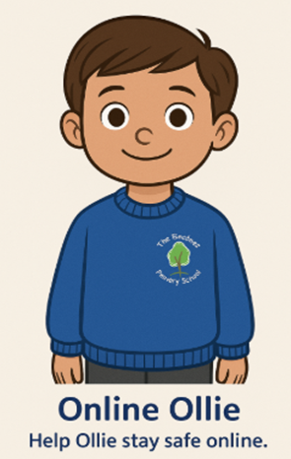 | Phase | Core Knowledge Focus
 | EYFS | Asking permission; online feelings
 | Year 1 | Kind online behaviour; personal info
 | Year 2 | People online may not be real
 | Year 3 | Cyberbullying; screen time balance
 | Year 4 | Protecting personal info; stranger risks
 | Year 5 | Digital footprint; scams
 | Year 6 | Evaluating online content; grooming risks

Wellbeing Willow
 | Phase | Core Knowledge Focus
 | EYFS | Identifying feelings; ways to feel better
 | Year 1 | Naming emotions; talking about worries
 | Year 2 | Managing worries; bullying response
 | Year 3 | Regulation strategies; wellbeing
 | Year 4 | Resilience and self-esteem
 | Year 5 | Coping strategies; mental health awareness
 | Year 6 | Transition wellbeing; seeking support

Worldwise Wren
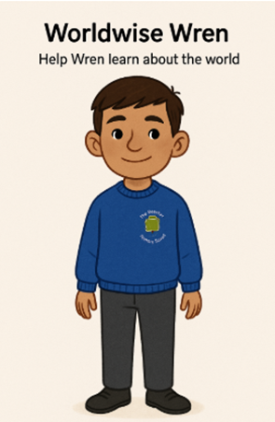 | Phase | Core Knowledge Focus
 | EYFS | Helping others; rules
 | Year 1 | Community roles; shared places
 | Year 2 | Rights and responsibilities
 | Year 3 | Importance of laws; diversity
 | Year 4 | Democracy; needs vs wants
 | Year 5 | Human rights; stereotypes
 | Year 6 | Challenging discrimination

 | Phase | Core Knowledge Focus
 | EYFS | Bodies grow and change
 | Year 1 | Healthy habits; emotions about change
 | Year 2 | Normal body changes
 | Year 3 | Growth at different rates
 | Year 4 | Body confidence
 | Year 5 | Puberty changes and reproduction
 | Year 6 | Managing puberty safely

Appendix 2: By the end of primary school pupils should know
Topic | Pupils should know
Families and people who care for me | - That families are important for children growing up because they can give love, security and stability  - The characteristics of safe and happy family life, such as: commitment to each other, including in times of difficulty, protection and care for children and other family members, the importance of spending time together and sharing each other’s lives  - That other children’s families, either in school or in the wider world, sometimes look different from their own, but they should respect those differences and know that other families are also characterised by love and care  - That stable, caring relationships are at the heart of safe and happy families, and are important for children’s security as they grow up  - That marriage and civil partnerships represent a formal and legally recognised commitment of 2 people to each other which is intended to be lifelong  - How to recognise if family relationships are making them feel unhappy or unsafe, and how to seek help or advice from others if needed
Caring friendships | - How important friendships are in making us feel happy and secure, and how people choose and make friends  - The characteristics of friendships that lead to happiness and security, including: mutual respect, truthfulness, trust and trustworthiness, loyalty, kindness, generosity, sharing interests and experiences and support with problems and difficulties  - That healthy, caring and kind friendships are positive and welcoming towards others, and do not make others feel lonely or excluded. Pupils should learn skills for developing caring, kind friendships  - That not every child will have the friends they would like at all times, that most people feel lonely sometimes, and that there is no shame in feeling lonely or talking about it  - That most friendships have ups and downs, and that these can often be worked through so that the friendship is repaired or even strengthened  - About managing conflict with kindness and respect, and that violence is never right  - How to recognise when a friendship is making them feel unhappy or uncomfortable, and how to seek help or advice from others, if needed
Respectful, kind relationships | - The importance of respecting others, including in families and friendships. Pupils should be encouraged to discuss how we can balance the needs and wishes of different people, and why this can be complicated  - The importance of setting and respecting healthy boundaries in all relationships with friends, family, peers and adults  - How to communicate effectively: how to be assertive and express needs and boundaries and manage feelings, including disappointment and frustration  - That they can expect to be treated with respect and the importance of respecting others, including those who are different (for example: physically, in character, personality or background), or make different choices, or have different preferences or beliefs  - The practical steps they can take in a range of different contexts to improve or support their relationships  - The conventions of courtesy and manners  - The importance of self-respect and how this links to their own happiness. They should have opportunities to consider issues like self-esteem and building a sense of their own identity  - Pupils should have opportunities to discuss the difference between being assertive and being controlling, and the difference between being kind to other people and neglecting your own needs.  - About different types of bullying (including cyberbullying), the impact of bullying, responsibilities of bystanders (primarily reporting bullying to an adult) and how to get help  - How to seek help when needed, including when they are concerned about violence, harm, or when they are unsure who to trust  - What a stereotype is, and how stereotypes can be unfair, negative or destructive or lead to bullying and how to challenge a stereotype
Online safety and awareness | - That people sometimes behave differently online, including by pretending to be someone they are not and/or pretending to be a child  - That the same principles apply to online relationships as to face-to face relationships, including the importance of respect for others online including when we are anonymous  - The rules and principles for keeping safe online, how to recognise risks, harmful content and contact, and how to report them  - That there is a minimum age for joining most social media sites which protects children from inappropriate content or unsafe content with older social media users, who may be strangers, including other children and adults  - That it’s important to be cautious about sharing any information about themselves online, and how to use privacy and location settings to protect their information online  - How to critically consider their online friendships and sources of information, including awareness of the risks associated with people they have never met  - How information and data is shared and used online, including where pictures or words might be circulated  - Online risks, including that any material provided online might be circulated, and that once a picture or words has been circulated there is no way of deleting it everywhere and no control over where it ends up  - That the internet contains a lot of content that can be inappropriate and upsetting for children, and where to go for advice and support when they feel worried or concerned about something they have seen or engaged with online
Being safe | - What sorts of boundaries are appropriate in friendships with peers and others (including in a digital context). This can include learning about boundaries in play and in negotiations about space, toys, books, resources for example  - About the concept of privacy and the implications of it for both children and adults, including that it’s not always right to keep secrets if they relate to being safe  - That each person’s body belongs to them, and the differences between appropriate and inappropriate or unsafe physical, and other, contact  - How to respond safely and appropriately to adults they may encounter (in all contexts, including online) including those they do/don’t know  - How to recognise when a relationship is harmful or dangerous, including skills for recognising who to trust and who not to trust  - How to report concerns or abuse, about something seen online or experienced in real life, or feelings of being unsafe or feeling bad about any adult, and the vocabulary and confidence needed to do so  - Where to get advice, for example from their family, school and/or other sources

Appendix 3: Parent/carer form requesting their child’s withdrawal from sex education within RSE
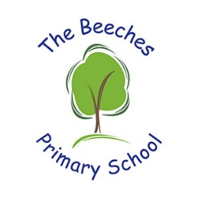
To be completed by parents/CARERS
Name of child |  | Class
Name of parent/carer |  | Date
Reason for withdrawing from sex education within relationships and sex education
Any other information you would like the school to consider
Parent/carer signature

To be completed by the school
Agreed actions from discussion with parents/carers

