The Beeches Primary School – Big Ideas & Aspects
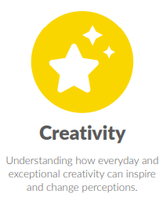
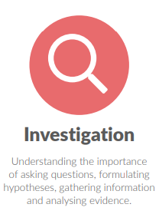
Art
Big Idea: Investigation
Big Idea: Creativity
- Creation
- Generation of ideas
- Evaluation
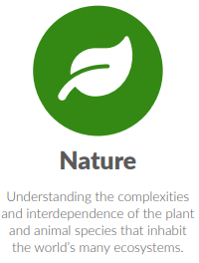
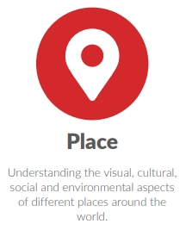
Big Idea: Place
- Landscapes
Big Idea: Nature
- Natural art
Big Idea: Humankind
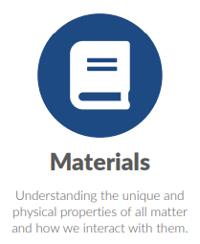
- Human form
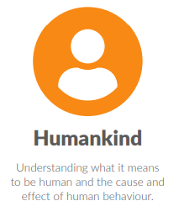
Big Idea: Materials
- Malleable materials
- Paper and fabric
- Paint
- Pencil, ink, charcoal and pen
- Printing
Big Idea: Comparison
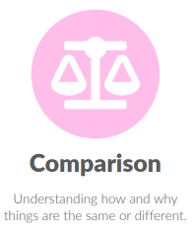
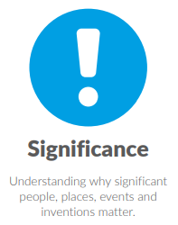
- Compare and contrast
Big Idea: Significance
- Significant people, artwork and movements
Big Idea: Processes
Big Idea: Change



