The Beeches Primary School – Big Ideas & Aspects
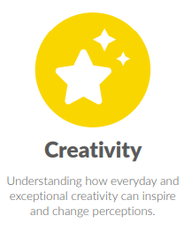
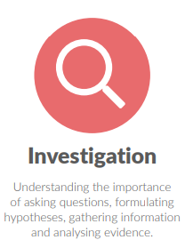
Design Technology
Big Idea: Investigation
- Investigation
- Evaluation
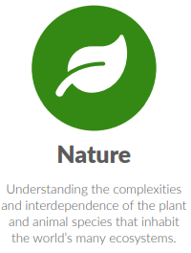
Big Idea: Creativity
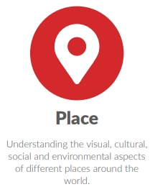
- Generation of ideas
- Use of ICT
- Structures
Big Idea: Place
Big Idea: Nature
- Food preparation and cooking
- Nutrition
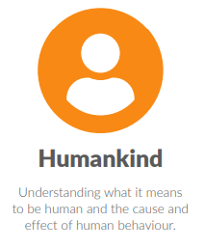
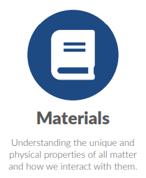
- Origins of food
Big Idea: Humankind
- Everyday products
- Staying safe
Big Idea: Materials
- Materials for purpose
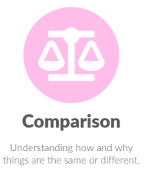
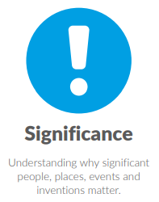
Big Idea: Comparison
- Compare and contrast
Big Idea: Significance
- Significant people
Big Idea: Processes
- Electricity
- Mechanisms and movement
Big Idea: Change


