The Beeches Primary School – Big Ideas & Aspects
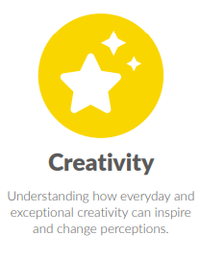
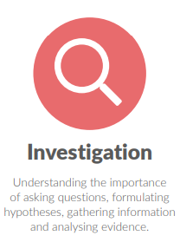
PSHCE
Big Idea: Investigation
- Issues, evidence and ideas
- Media
Big Idea: Creativity
- Vocabulary
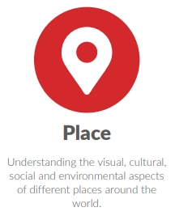
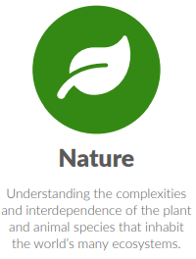
- Speaking, listening & sharing
Big Idea: Place
- Diversity
- Place in the world
Big Idea: Nature
- Rights of others
Big Idea: Humankind
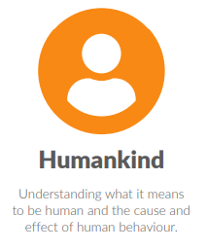
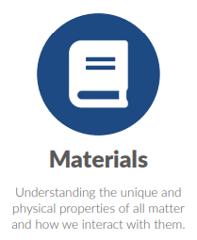
- Healthy lifestyles
- Setting goals
- Personal hygiene
- Staying safe
- Well-being
- Unacceptable behaviour
Big Idea: Materials
- Consumers
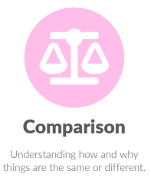
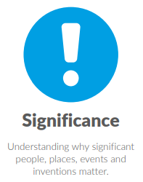
Big Idea: Comparison
- Compare and contrast
Big Idea: Significance
- Significant people
- Relationships
Big Idea: Processes
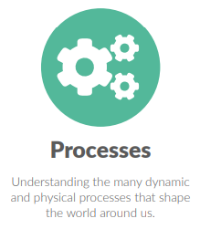
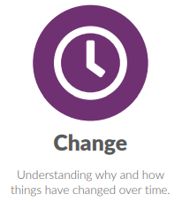
Big Idea: Change
- Physical development
- Life changes

