The Beeches Primary School – Big Ideas & Aspects
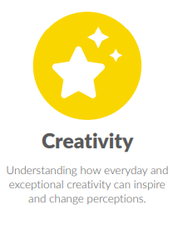
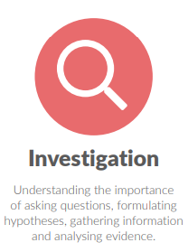
Computing

Big Idea: Investigation
- Data and computational thinking
- Networks
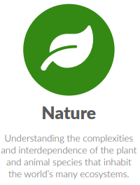
Big Idea: Creativity
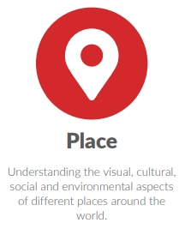
- Creation
Big Idea: Place
- Digital world
- Real world
Big Idea: Nature
- Real world
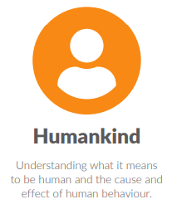
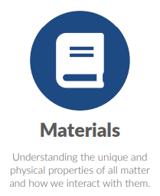
Big Idea: Humankind
- Communication
- Staying safe
- Digital citizenship
Big Idea: Materials
- Hardware
- Software
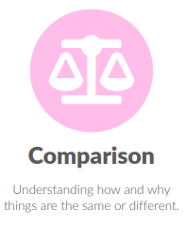
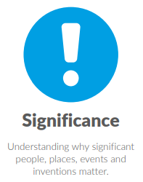
Big Idea: Comparison
- Digital Searching
Big Idea: Significance
Big Idea: Processes
- Physical interactions
Big Idea: Change


